Data Source Geolocation Service
This section provides some additional technical details about the data source mapping service, which geolocates all available DiverSea case study data sources on the world map live, in real-time. The service is accessible at https://datamap-diversea.gate-ai.eu/ and does not require any credentials to be used. Fig. 3 shows the map of the data sources produced by the service while browsing the Hellenic Volcanic Arch area of Aegean Sea.
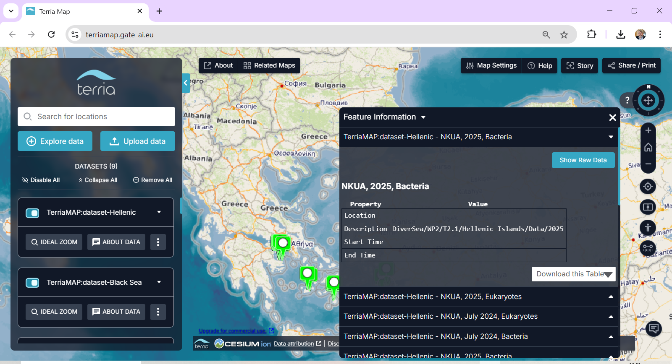
Figure 3. Data Sources from Hellenic Volcanic Arc in Aegean Sea (https://datamap-diversea.gate-ai.eu)
Apart from interactive moving around the globe in real time to geolocate the data sources, the service allows to see some additional information about the datasets containing data in DiverSea raw data repository from these data sources, obtained from the metadata if the datasets. Tab. 3 contains description of all operations together with the parameters they use.
Operation | Parameters | Description | Tools
Spatial  navigation | Data source,  Geolocation  Coordinates | Obtaining the geographic location coordinates for the chosen data source by clicking the map | JavaScript, Terria, Cesium
Request  formulation | Database,  Dataset | Query formulation, connecting to the server, accessing the repository and executing a sequence of SQL commands | GeoServer,  PostGIS,  PostgreSQL
Information retrieval | Case study, Time,  Institution, Content, Stats | Retrieving the metadata using SQL DDL and dataset statistics using SQL DML and combining it with the mapping information | PostgreSQL,  PostGIS,  GeoServer
Information  presentation | Current information as retrieved | Presenting the retrieved information next to the data source location in a pop-up window | 3D Geospatial, Cesium, Terria, JS
Table 3. Mapping Service Operations
Inquiries linked to its use can be sent to the service administrator (email: viktor.sowinski@gate-ai.eu).

